CSA4723-DEEP LEARNING FOR DISASTER MANAGEMENT
V.SREE RUTHIN REDDY
192324112

1.Construct and verify the performance of bi-level and multi-level confusion
matrix using Python.
AIM: To Construct and verify the performance of bi-level and multi-level confusion
matrix using Python.

ALGORITHM:
- Import matplotlib.pyplot and seaborn.
- Create a figure with a specific size.
- Set up a subplot (1 row, 2 columns, first plot).
- Draw a heatmap of the confusion matrix (multi_level_cm).
- Add a title to the plot.
- Adjust layout to fit well.
- Show the plot.

PROGRAM:
import matplotlib.pyplot as plt
import seaborn as sns
plt.figure(figsize=(12, 5))
plt.subplot(1, 2, 1) # 1 row, 2 columns, 1st subplot
sns.heatmap(multi_level_cm, annot=True, fmt='d', cmap='Blues', cbar=True)
plt.title('Multi-level Confusion Matrix')
plt.tight_layout()
plt.show()

OUTPUT
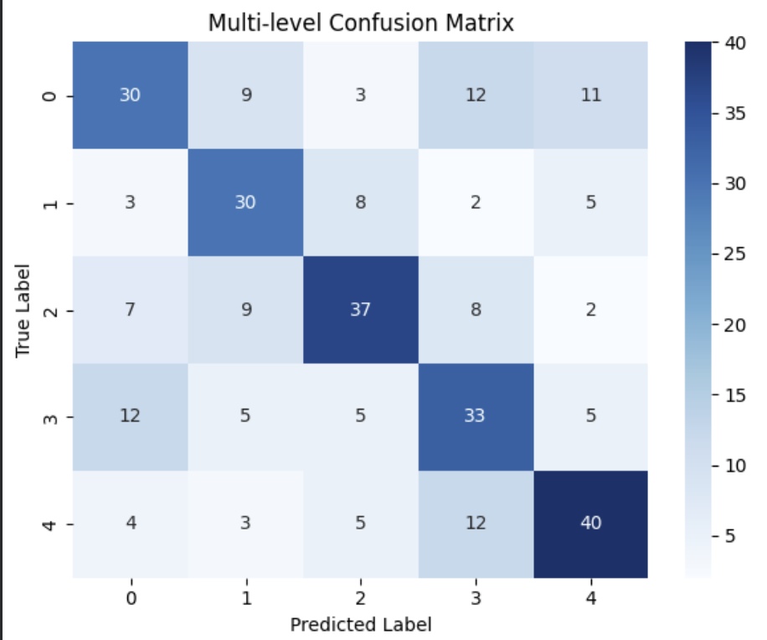

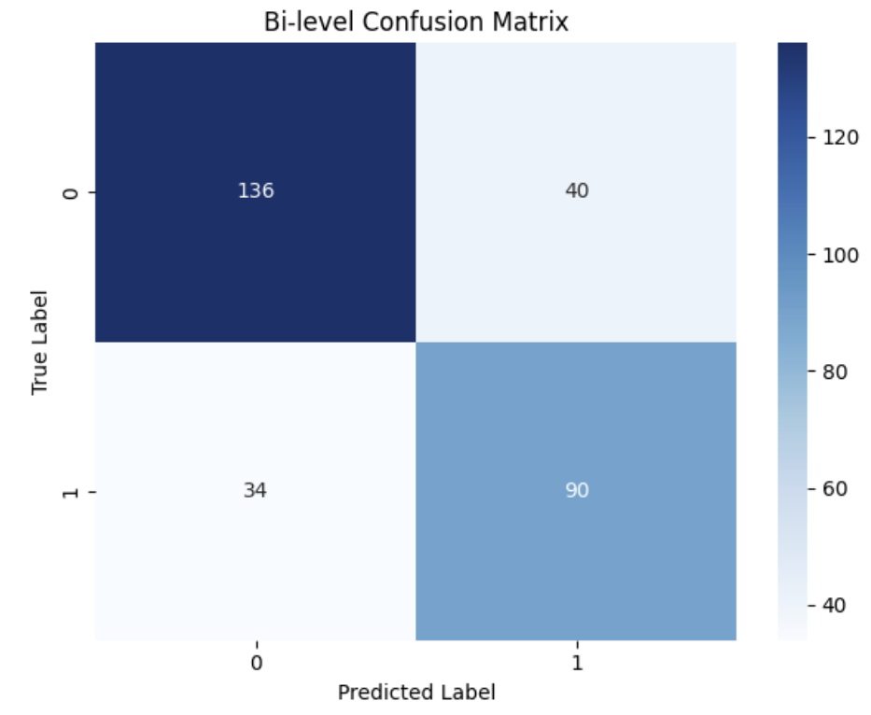

2. Verification of the overfitting issue by using a chosen numerical database using
Python.
AIM: Verification of the overfitting issue by using a chosen numerical database using
Python.
from sklearn.datasets import load_wine
from sklearn.model_selection import train_test_split
from sklearn.tree import DecisionTreeClassifier
from sklearn.metrics import accuracy_score
import matplotlib.pyplot as plt

# Load numerical dataset (Wine dataset)
data = load_wine()
X = data.data
y = data.target
# Split data: 70% training, 30% testing
X_train, X_test, y_train, y_test = train_test_split(X, y, test_size=0.3, random_state=42)
# Model 1: Overfitted Decision Tree (no depth limit)
overfit_model = DecisionTreeClassifier(random_state=42)
overfit_model.fit(X_train, y_train)
train_acc_over = accuracy_score(y_train, overfit_model.predict(X_train))
test_acc_over = accuracy_score(y_test, overfit_model.predict(X_test))
print("🔹 Overfitted Model (No Depth Limit)")
print(f"Training Accuracy: {train_acc_over:.3f}")
print(f"Testing Accuracy: {test_acc_over:.3f}")
# Model 2: Regularized Decision Tree (with max_depth)
regularized_model = DecisionTreeClassifier(max_depth=3, random_state=42)
regularized_model.fit(X_train, y_train)
train_acc_reg = accuracy_score(y_train, regularized_model.predict(X_train))
test_acc_reg = accuracy_score(y_test, regularized_model.predict(X_test))
print("\n🔹 Regularized Model (max_depth=3)")
print(f"Training Accuracy: {train_acc_reg:.3f}")
print(f"Testing Accuracy: {test_acc_reg:.3f}")
# Visualization of Overfitting
plt.figure(figsize=(7, 5))
bars = plt.bar(["Overfit Train", "Overfit Test", "Reg Train", "Reg Test"],
[train_acc_over, test_acc_over, train_acc_reg, test_acc_reg],
color=["skyblue", "lightcoral", "limegreen", "orange"])
plt.title("Verification of Overfitting (Wine Dataset)")
plt.ylabel("Accuracy")
plt.ylim(0, 1.05)
# Annotate accuracy values on the bars
for bar in bars:
height = bar.get_height()
plt.text(bar.get_x() + bar.get_width()/2, height - 0.05,
f"{height:.2f}", ha='center', color='black', fontsize=10)
plt.show()
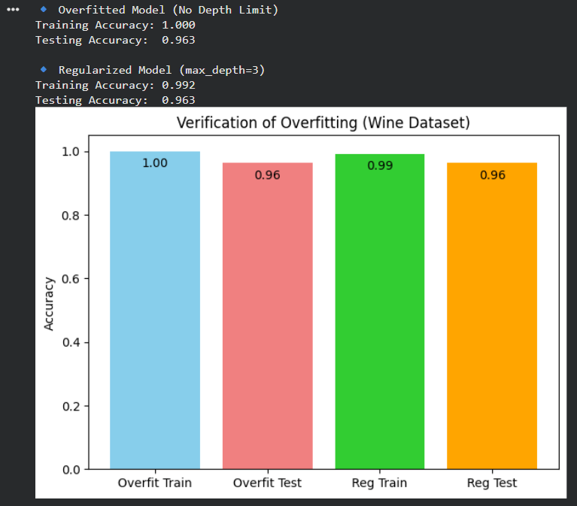
3. Analysing the performance of linear regression process using a chosen
numerical database using Python.

from sklearn.datasets import fetch_california_housing
from sklearn.model_selection import train_test_split
from sklearn.linear_model import LinearRegression
from sklearn.metrics import mean_absolute_error, mean_squared_error, r2_score
import matplotlib.pyplot as plt
import numpy as np
# Step 1: Load dataset
data = fetch_california_housing()
X = data.data
y = data.target
# Step 2: Split dataset (70% train, 30% test)
X_train, X_test, y_train, y_test = train_test_split(X, y, test_size=0.3, random_state=42)
# Step 3: Train Linear Regression Model
model = LinearRegression()
model.fit(X_train, y_train)
# Step 4: Predict on Test Data
y_pred = model.predict(X_test)
# Step 5: Evaluate Performance
mae = mean_absolute_error(y_test, y_pred)
mse = mean_squared_error(y_test, y_pred)
rmse = np.sqrt(mse)
r2 = r2_score(y_test, y_pred)
print("🔹 Linear Regression Performance Analysis 🔹")
print(f"Mean Absolute Error (MAE): {mae:.3f}")
print(f"Mean Squared Error (MSE): {mse:.3f}")
print(f"Root Mean Squared Error (RMSE): {rmse:.3f}")
print(f"R² Score: {r2:.3f}")
# Step 6: Visualization
plt.figure(figsize=(6,6))
plt.scatter(y_test, y_pred, color='blue', edgecolor='k', alpha=0.6)
plt.plot([y_test.min(), y_test.max()], [y_test.min(), y_test.max()], 'r--', lw=2)
plt.title("Actual vs Predicted Values (Linear Regression)")
plt.xlabel("Actual Prices")
plt.ylabel("Predicted Prices")
plt.show()
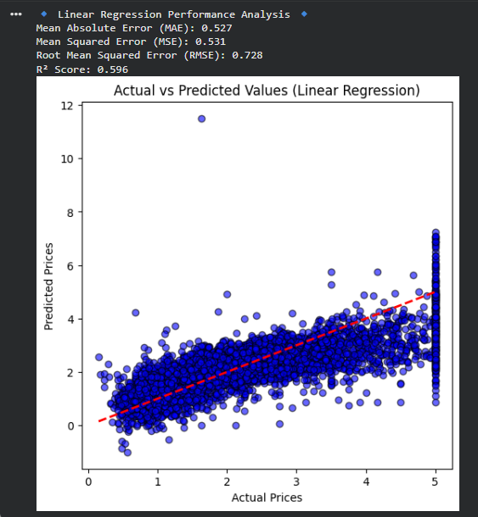
4. Analysing the performance of logistic regression process using a chosen
numerical database using Python
# ✅ Analysing the Performance of Logistic Regression using a Numerical Dataset

from sklearn.datasets import load_iris
from sklearn.model_selection import train_test_split
from sklearn.linear_model import LogisticRegression
from sklearn.metrics import confusion_matrix, classification_report, accuracy_score
import seaborn as sns
import matplotlib.pyplot as plt
data = load_iris()
X = data.data
y = data.target
X_train, X_test, y_train, y_test = train_test_split(X, y, test_size=0.3, random_state=42)
model = LogisticRegression(max_iter=200)
model.fit(X_train, y_train)
y_pred = model.predict(X_test)
acc = accuracy_score(y_test, y_pred)
cm = confusion_matrix(y_test, y_pred)
report = classification_report(y_test, y_pred)
print("🔹 Logistic Regression Performance Analysis 🔹")
print(f"Accuracy: {acc:.3f}\n")
print("Classification Report:\n", report)
plt.figure(figsize=(6,5))
sns.heatmap(cm, annot=True, fmt='d', cmap='Blues', cbar=False,
xticklabels=data.target_names, yticklabels=data.target_names)
plt.title("Confusion Matrix - Logistic Regression")
plt.xlabel("Predicted Labels")
plt.ylabel("True Labels")
plt.show()
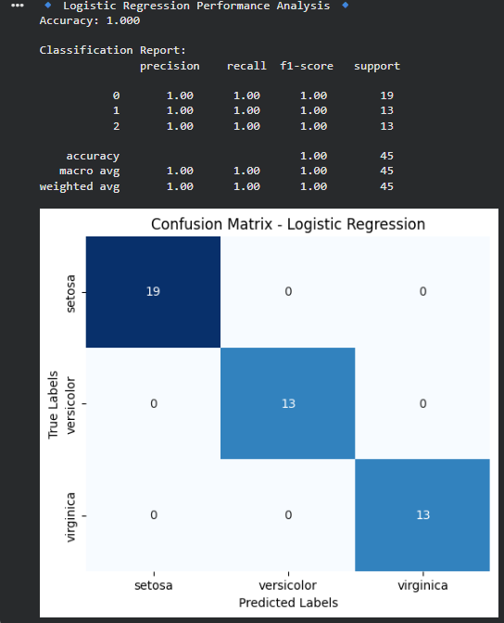

5.Demonstrating the performance of gradient descent algorithm using Python
import numpy as np
import matplotlib.pyplot as plt

# -----------------------------
# Step 1: Create a simple linear dataset
# -----------------------------
np.random.seed(42)
X_gd = 2 * np.random.rand(100, 1) # Renaming to avoid conflict with existing X
…plt.title('Gradient Descent: Cost History')
plt.xlabel('Iterations')
plt.ylabel('Cost (MSE)')
plt.legend()
plt.grid(True, linestyle='--', alpha=0.6)

plt.tight_layout()
plt.show()
OUTPUT

